The primary sex organ of female reproductive system is ______
A. Fallopian Tubes
B. Ovaries
C. Uterus
D. Cervix
ANSWER: B
What is the process of the formation of a mature female gamete called?
A. Menstruation
B. Spermatogenesis
C. Oogenesis
D. Ovulation
ANSWER: C
Finger-like structure above the urethral opening is called ______
A. Vulva
B. Clitoris
C. Vagina
D. Labia minora
ANSWER: B
The female gonads are a pair of
A. Testes
B. Ovaries
C. Penis
D. Cervix
ANSWER: B
Embryo develops in
A. Uterus
B. Cervix
C. Vagina
D. None of these
ANSWER: A
At the bottom of the uterus is a narrow opening called the
A. Uterus
B. Cervix
C. Vagina
D. Ovaries
ANSWER: B
Cervix leads into a muscular tube called
A. Uterus
B. Cervix
C. Vagina
D. Ovaries
ANSWER: C
_____________is used for the reception of sperms and delivery of foetus.
A. Uterus
B. Cervix
C. Vagina
D. Ovaries
ANSWER: C
The wall of the uterus is made up of ______layers
A. Two
B. Four
C. Three
D. Five
ANSWER: C
The hormones FSH and LH are involved in oogenesis in women. When LH surges in the ovarian cycle, what event will result?
A. Menstruation
B. Ovulation
C. None
D. Corpus luteum degradation
ANSWER: B
Female sex cells, or gametes, develop in the ovaries by a form of meiosis called
A. Spermatogenesis
B. Spermiation
C. Oogenesis
D. Gametogenesis
ANSWER: C
Finger-like projections surrounding the infundibulum called:
A. Clitoris
B. fimbriae
C. Villi
D. None
ANSWER: B
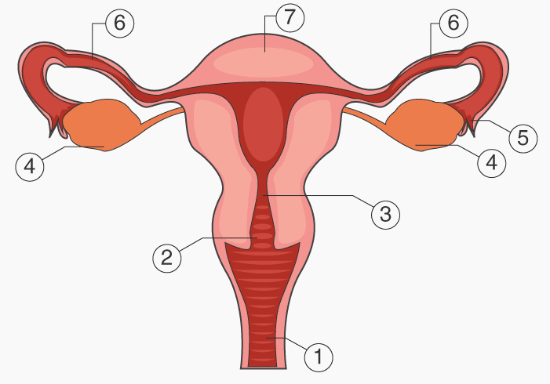
The diagram represents female reproductive system, identify the structure 1:
A. Vagina
B. Uterus
C. Fimbriae
D. Cervix
ANSWER: A

The diagram represents female reproductive system, identify the structure 2:
A. Vagina
B. Uterus
C. Fimbriae
D. Cervix
ANSWER: D

The diagram represents female reproductive system, identify the structure 5:
A. Vagina
B. Uterus
C. Fimbriae
D. Cervix
ANSWER: C

